Using **Tableau** do the following exercises:

* Recreate the image using the attached Data Set “abc.txt”. You can use the "id" field but it is not necessary to recreate the view.

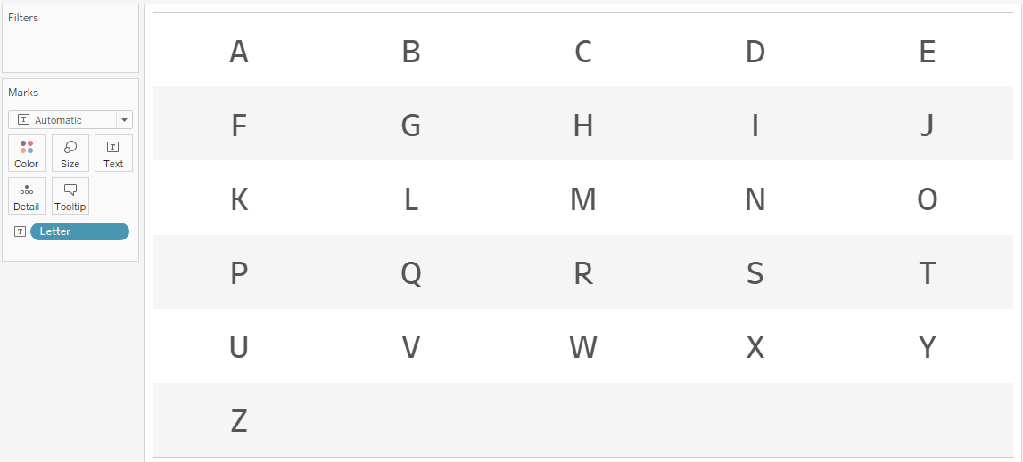

* We have a Data Set of sales by flight date. We want to have a view that shows us sales by week and day. The view has to show the current month, but with one condition, the weeks cannot be broken, they must go from Monday to Monday. If the current month starts on a Wednesday, the last two days (Monday-Tuesday) of the previous month must be out.

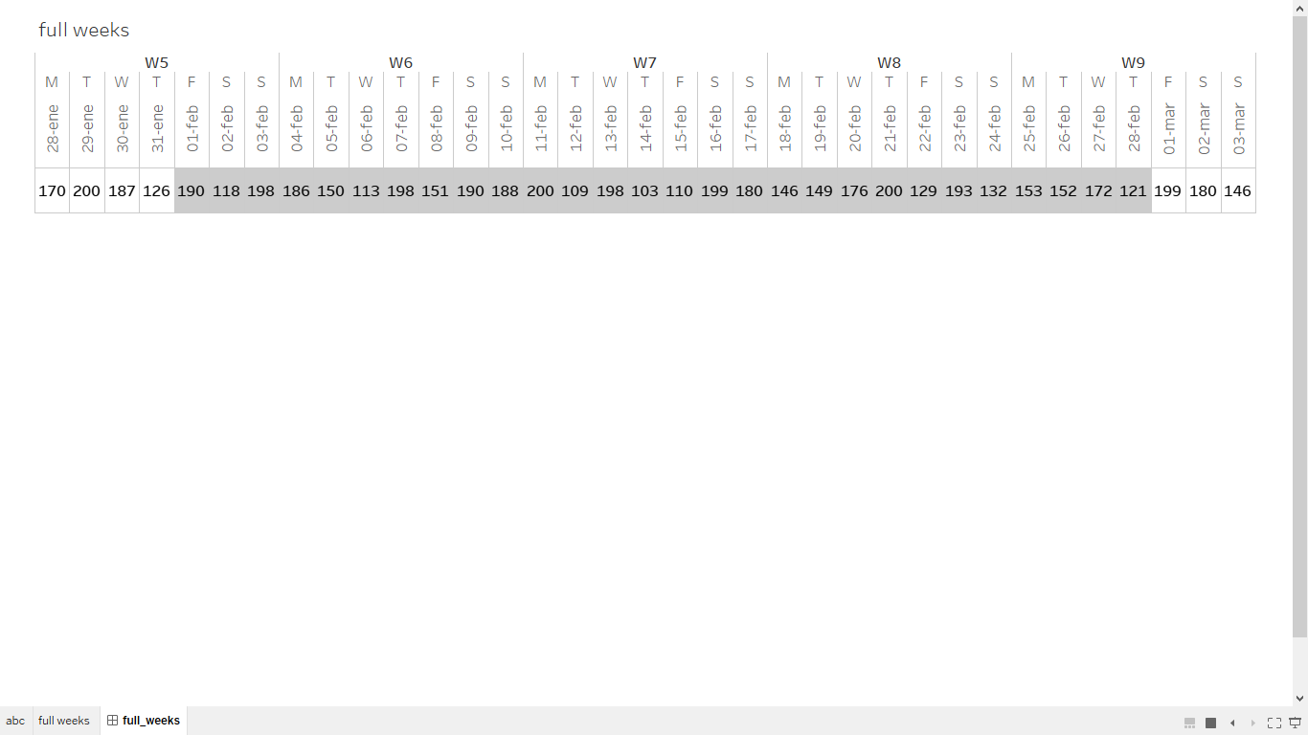

Recreate the view using the file full_weeks.xls

(The jump from week 53 to 1 is irrelevant)

* A date filter must be created to show sales where the current day is selected by default, but a specific day can be selected. (The day selector should only appear when I want a day that is not today) You can use the file: full_weeks.xls

